Analysis 4.1 How does the choice of different types of floors impact the changes in rental prices?

Based on the analysis, the Lower Floor rental prices are relatively low. The Medium Floor rental prices are relatively higher than Lower Floor. The Upper Floor rental prices are relatively higher than Medium Floor. In conclusion, there is a statistically significant relationship between the floor category and rental price. The coefficients for Medium Floor and Upper Floor are positive and significant. This means that rental prices increase. The model explained about 15% of why the rental prices change is because of the floor type and choosing the Upper Floor seems to come with higher rent price.

Analysis 4.2 How does the choice of different types of floors impact the changes in rental prices in Kolkata City?

Based on the analysis, Kolkata only has lower and medium floors, with no upper floors that are 20 floors or above. The median rental price for Lower Floors is 8,500, which is higher than the median rental price of 8,000 for Medium Floors. This shows that in Kolkata, Lower Floors may have higher rental prices than Medium Floors. Therefore, it can be concluded that the choice of different types of floors is an important factor that affects changes in rental prices in Kolkata City.

Analysis 4.3 How does the choice of different types of floors impact the changes in rental prices in Mumbai City?

Based on the analysis, units from medium floors and upper floors have higher rental price compared to lower floor in Mumbai. In conclusion, both medium and upper Floor have positive and significant coefficients, show that choosing a Medium Floor or Upper Floor results in an increase in rental price compared to Lower Floor. The increase in rental price is greater for Upper Floor than for Medium Floor. The model explained about 9.34% of the variation in rental prices can be explained to the choice of different types of floors. Therefore, it can be concluded that the choice of different types of floors is an important factor that affects the changes in rental prices in Mumbai City.

Analysis 4.4 How does the choice of different types of floors impact the changes in rental prices in Bangalore City?

Based on the analysis, units from medium floors and upper floors have higher rental price compared to lower floors in Banglore. In conclusion, both medium and upper floor have positive and significant coefficients, show that choosing a Medium Floor or Upper Floor results in an increase in rental price compared to Lower Floor. The increase in rental price is greater for upper floor than for medium floor. The model explained about 6.55% of the variation in rental prices can be explained to the choice of different types of floors. Therefore, it can be concluded that the choice of different types of floors is an important factor that affects the changes in rental prices in Bangalore City.

Analysis 4.5 How does the choice of different types of floors impact the changes in rental prices in Delhi City?

Based on my analysis, there are no medium and upper floor in Delhi. In this case, it is not possible to determine how the choice of different types of floors impact the changes in rental prices in Delhi City. However, the analysis would be limited to the rental prices for Lower Floor only. The summary of the Rental Prices of Lower Floor in Delhi show that the minimum rental price is 2,000, the first quartile is 11,000, the median is 17,000, the mean is 29,462, the third quartile is 30,000, and the maximum rental price is 530,000. Conclusion, it is not possible to determine if there has been an increase in rental prices in Delhi.

Analysis 4.6 How does the choice of different types of floors impact the changes rental prices in Chennai City?

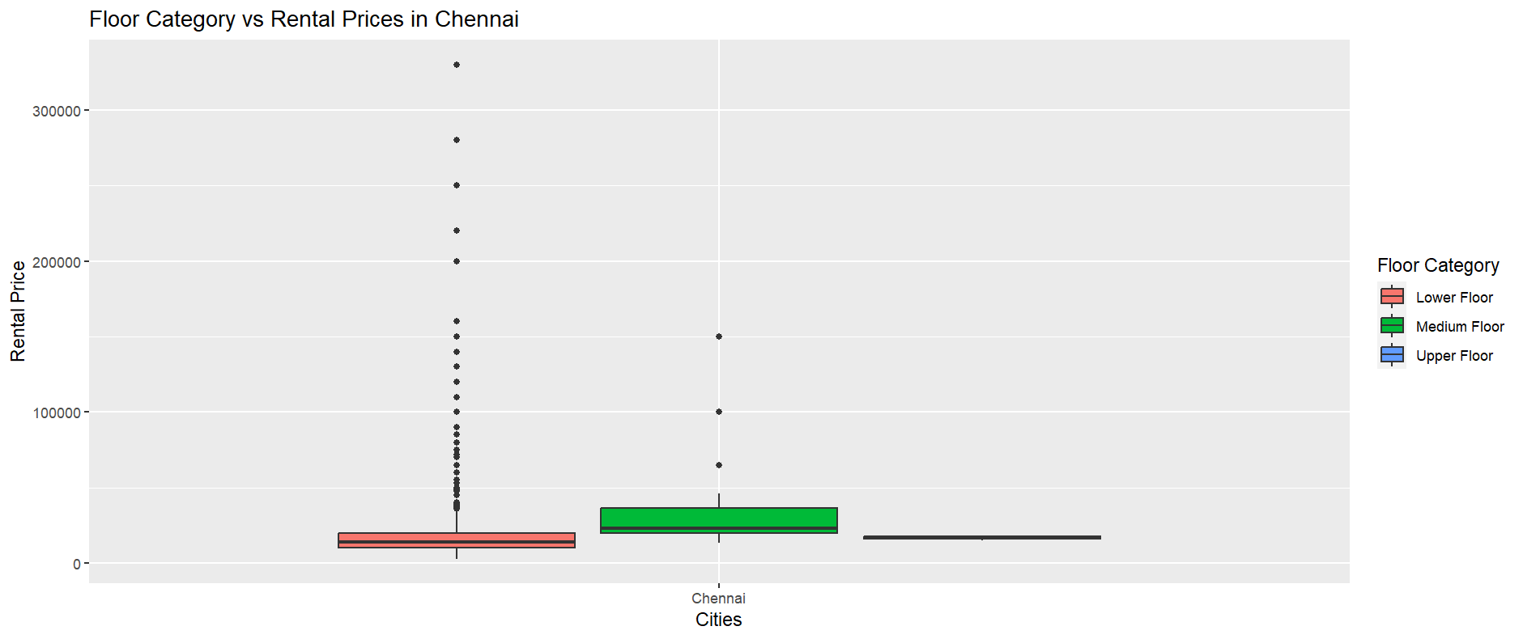

Based on my analysis, the units from medium floor have higher rental price compared to lower floors. However, rental price for upper floor are not significantly different compared to those choosing for Lower Floor. In conclusion, the coefficient for medium floor is positive and significant, means that choosing a Medium Floor will results an increase in rental price. However, the upper floor is not significant difference compared to Lower Floor in rental price. The model explained about 0.83% of the variation in rental prices can be explained to the choice of different types of floors. Therefore, it can be concluded that the choice of different types of floors is an important factor that affects the changes in rental prices in Chennai City.

Analysis 4.7 How does the choice of different types of floors impact the changes in rental prices in Hyderabad?

Based on my analysis, units from medium and upper floors are higher rental price compared to lower floors. In conclusion, both medium and upper floor have positive and significant coefficients, show that choosing a medium floor or upper floor results in an increase in rental price compared to lower floor. The increase in rental price is greater for medium floor than for upper floor. The model explains about 10.04% of the variation in rental prices can be explained to the choice of different types of floors. Therefore, it can be concluded that the choice of different types of floors is an important factor that affects the changes in rental prices in Hyderabad City.

Analysis 4.8 Are there significant differences in rental prices based on different floor categories across different cities?

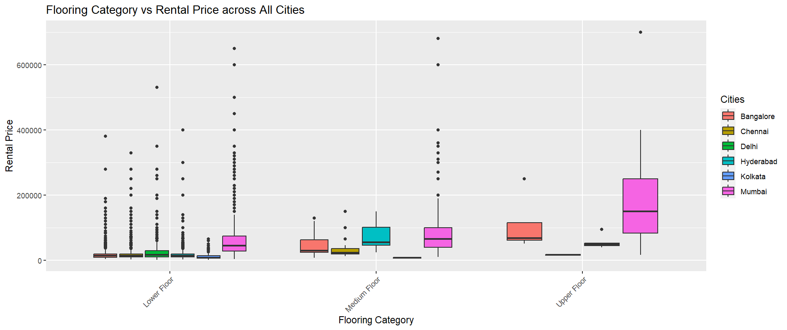

According to my observation, units from medium and upper floors have higher rental prices compared to lower floors, across different cities. In conclusion, the floor category and city are significant predictors of rental price. Rental prices also vary significantly between cities, with Mumbai having the highest rental prices and Kolkata having the lowest rental prices compared to the reference city of Bangalore. The model explains about 27.72% of the variance in rental price, suggesting that there may be other factors affecting rental price as well.

Analysis 4.9 How do different types of floors affect the rental prices based on whether the properties are furnished or not?

According to my observation, units from upper floors have higher rental prices compared to lower and medium floors. Furnished units also have higher rental prices compared to semi-furnished and unfurnished units. In conclusion, the floor category and furnishing status are significant predictors of rental prices. The model explains about 15.75% of the variance in rental price, suggesting that there may be other factors affecting rental price as well. Conclusion, the floor category and furnishing status have a significant affect rental price and units on upper floors and furnished tend to have higher rental prices.

Analysis 4.10 How does the combination of different flooring categories and furnishing statuses impact rental prices in Kolkata?

According to my observation, there is no clear relationship between floor category and rental price in Kolkata. However, the furnishing status is a significant predictor of rental price, with furnished properties having higher rental prices than semi-furnished and unfurnished properties. In conclusion, the floor category is not a significant predictor of rental price in Kolkata. However, the furnishing status is a significant predictor, with furnished having higher rental prices than semi-furnished and unfurnished. The model explains only about 1.61% of the variance in rental price, suggesting that there may be other factors affecting rental price as well.

Analysis 4.11 How does the furnishing status of properties interact with different floor categories to affect rental prices in Mumbai?

According to my observation, units from upper floors have higher rental prices compared to lower and medium floors in Mumbai. Furnished units also have higher rental prices compared to semi-furnished and unfurnished units. In conclusion, the floor category and furnishing status are significant predictors of rental prices in Mumbai. The model explains about 15.75% of the variance in rental price, suggesting that there may be other factors affecting rental price as well.

Analysis 4.12 How do different flooring categories and their corresponding furniture status affect the variation of rental prices in Bangalore?

According to my observation, units from medium floors and upper floors have higher rental prices compared to lower floors in Bangalore. Furnished units also have higher rental prices compared to semi-furnished and unfurnished units. In conclusion, the floor category and furnishing status are significant predictors of rental prices in Mumbai. The model explains about 9.13% of the variance in rental price, suggesting that there may be other factors affecting rental price as well.

Analysis 4.13 How does the choice of different types of floors and their corresponding furnishing statuses relate to changes in rental prices in Delhi?

According to my observation, there is no clear relationship between floor category and rental price in Delhi. However, the furnishing status is a significant predictor of rental price, with furnished units having higher rental prices compared to semi-furnished and unfurnished units. In conclusion, the floor category is not a significant predictor of rental prices in Delhi. However, the furnishing status is a significant predictor, with furnished units having higher rental prices compared to semi-furnished and unfurnished units.

Analysis 4.14 How does the combination of flooring categories and furnishing statuses influence the variation in rental prices in Chennai?

Based on my analysis, the floor category and furnishing status are significant impact of rental prices in Chennai. According to the linear regression model, the most important factor influencing rental price is whether a unit is unfurnished, showing rental prices that are -18287 lower than those of furnished units. Additionally, units on medium floors could potentially have higher rental prices by 15573. The model explains about 9.13% of the variance in rental price. There might be other factors affecting rental price.

Analysis 4.15 How do various flooring categories and furnishing statuses interact to affect rental prices in Hyderabad?

Based on my analysis, the floor category and furnishing status are significant impact of rental prices in Hyderabad. According to the linear regression model, the most important factor influencing rental price is whether a unit is unfurnished, showing rental prices that are -8317 lower than those of furnished units. Additionally, units on medium floors could potentially have higher rental prices by 51807, and units on upper floors could have rental prices higher by 32176 compared to units on lower floors. The model explains about 13.26% of the variance in rental price. There might be other factors affecting rental price.

Analysis 4.16 How does floor categories relate to rental prices based on the area size?

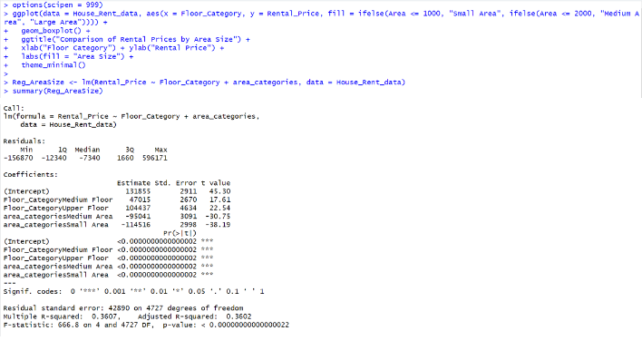

Based on my analysis, the floor category and the area size have a significant impact on rental prices. According to the linear regression model, the coefficients for Medium Size and Small Size are -95041 and -114516 showing have lower rental prices compared to Large Area. While the Medium Floor and Upper Floor are 47015 and 104437 have higher rental prices compared to lower floor. The model explains about 36.02% of the variance in rental price. There might be other factors affecting rental price.

Analysis 4.17 How does the combination of flooring category and area size impact the rental prices in Kolkata?

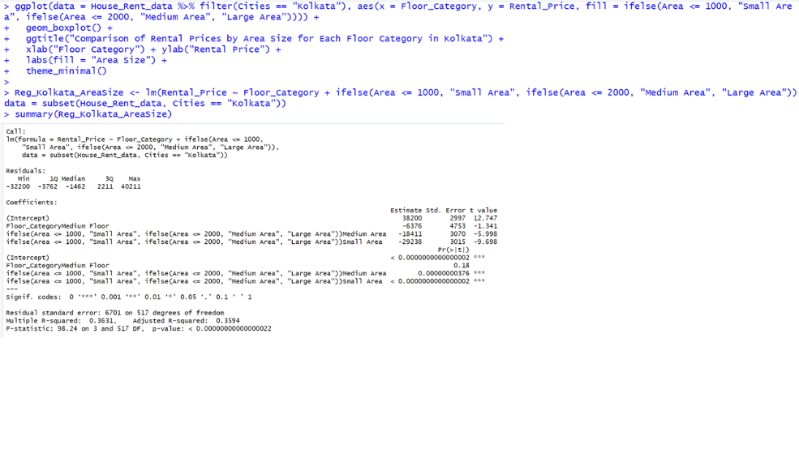

Based on my analysis, the floor category and the area size have a significant impact on rental prices in Kolkata. According to the linear regression model, the coefficients for Medium Area and Small Area are -18411 and -29238 have lower rental prices compared to Large Area. While the Medium Floor is -6376 have lower rental prices compared to Lower Floor. The model explains about 36.02% of the variance in rental price. There might be other factors affecting rental price.

Analysis 4.18 How does the interaction between flooring category and area size influence rental prices in Mumbai?

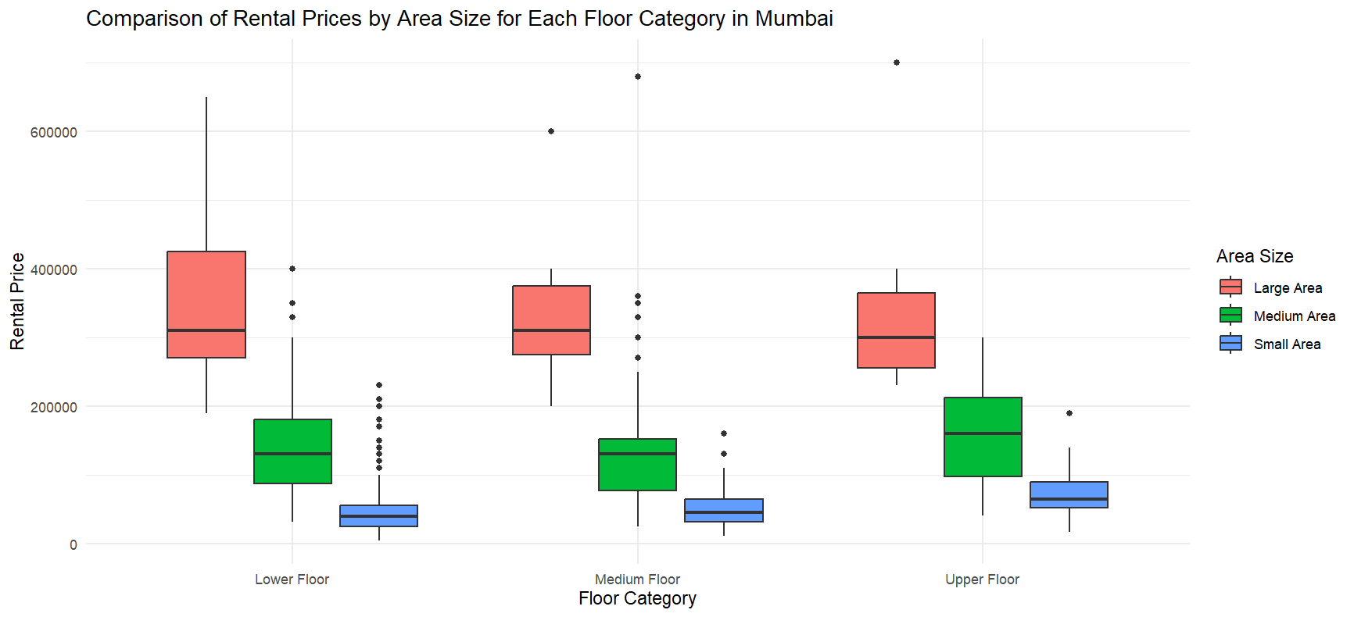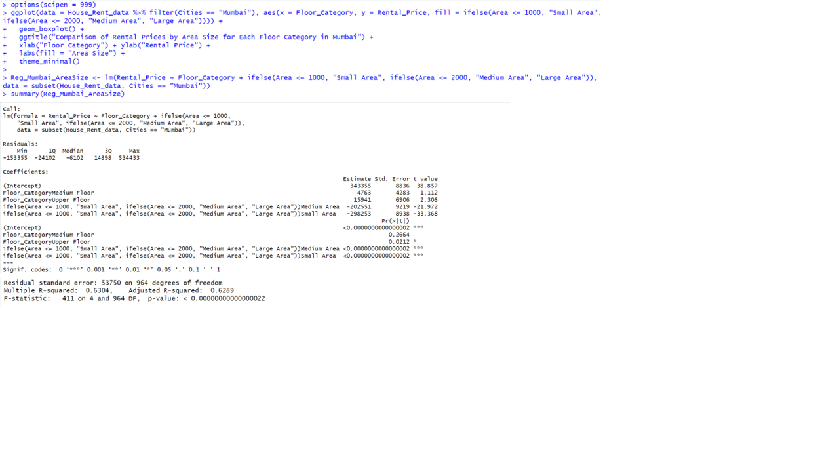

Based on my analysis, the floor category and the area size have a significant impact on rental prices in Mumbai. According to the linear regression model, the coefficients for Medium Size and Small Size are -202551 and -298253 showing have lower rental prices compared to Large Area. While the Medium Floor and Upper Floor are 4763 and 15941 have higher rental prices compared to lower floor. The model explains about 63.04% of the variance in rental price. There might be other factors affecting rental price.

Analysis 4.19 Does the comparison of flooring category and area size have an impact on rental prices in Bangalore?

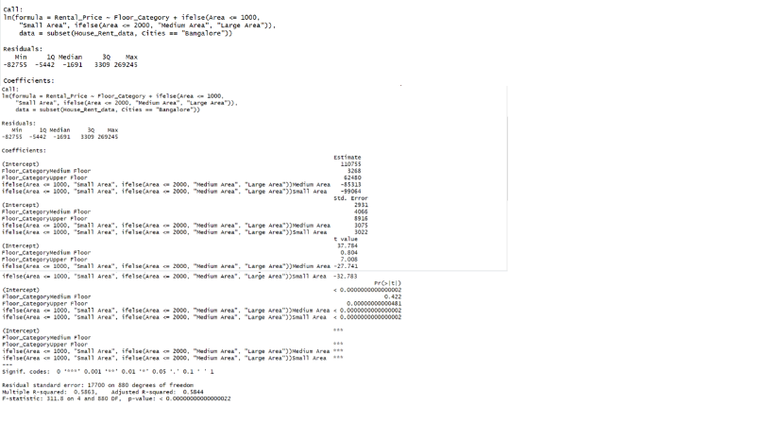

Based on my analysis, the floor category and the area size have a significant impact on rental prices in Mumbai. According to the linear regression model, the coefficients for Medium Size and Small Size are -85313 and -99064 showing have lower rental prices compared to Large Area. While the Medium Floor and Upper Floor are 110755 and 3268 have higher rental prices compared to lower floor. The model explains about 58.63% of the variance in rental price. There might be other factors affecting rental price.

Analysis 4.20 Does the relationship between flooring category and area size have an impact on rental prices in Delhi?

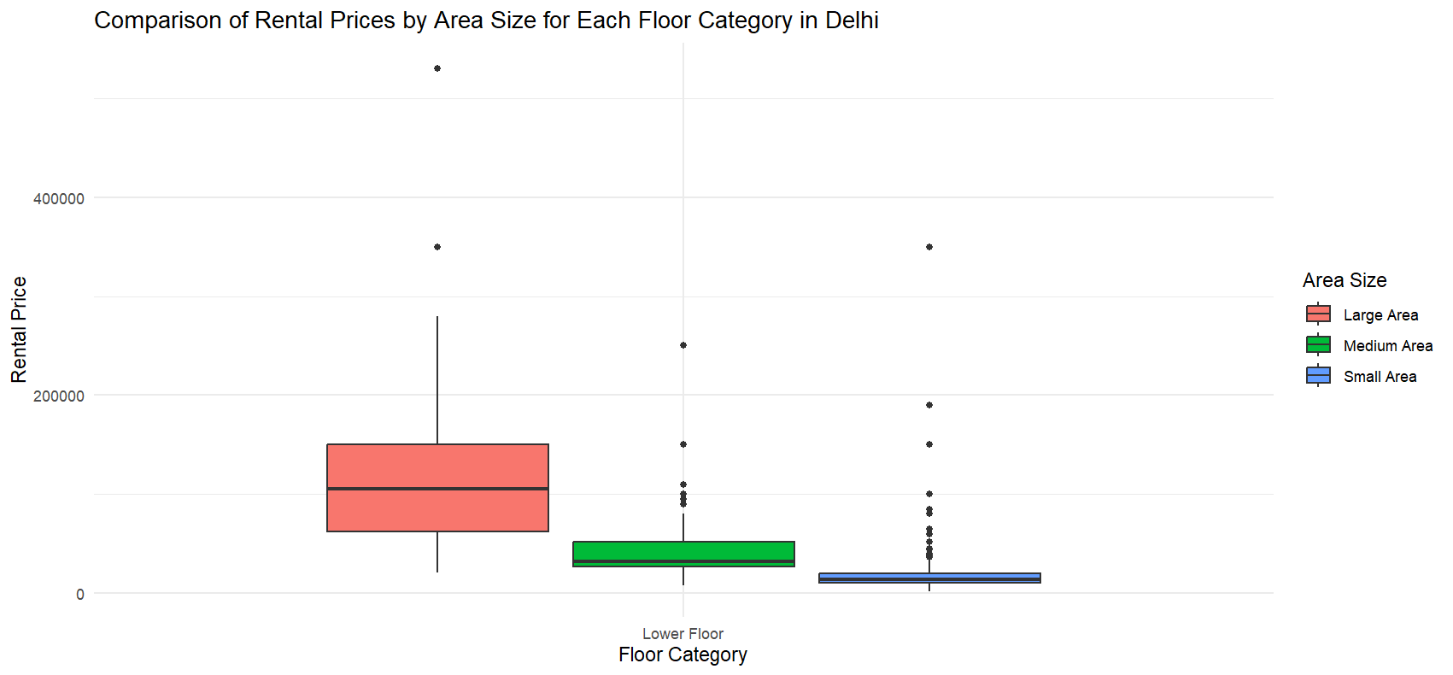

According to my observation, there is no clear relationship between floor category and rental price in Delhi. However, the area size is a significant predictor of rental price, with large area having higher rental prices compared to medium area and small area. In conclusion, the floor category is not a significant predictor of rental prices in Delhi. However, the area size is a significant predictor, with large area having higher rental prices compared to medium area and small area.

Analysis 4.21 Does the combination of flooring category and area size influence rental prices in Hyderabad?

Based on my analysis, the floor category and the area size have a significant impact on rental prices in Mumbai. According to the linear regression model, the coefficients for Medium Size and Small Size are -53214 and -61738 showing have lower rental prices compared to Large Area. While the Medium Floor and Upper Floor are 27328 and 26537 have higher rental prices compared to lower floor. The model explains about 42.32% of the variance in rental price. There might be other factors affecting rental price.

Analysis 4.22 Exploring Flooring Category, Area Size, Furnishing Status Impact on Rental Price all Cities

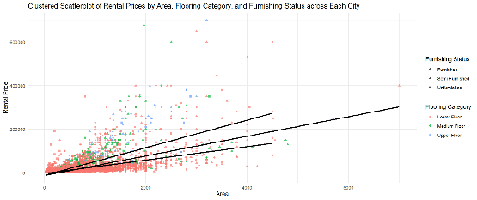

According to the linear regression model, the p-value is extremely low and have a significant relationship between all factors. I observed the scatter plot shows that the rental price increases with the area size, with most of the data points gathered around a rental price of 2000 and an area size of 2000. In addition, the city with the highest impact on the rental price is Mumbai with a coefficient of 58352.9691 which is the highest among all cities.

Analysis 4.23 Exploring Flooring Category, Area Size, Furnishing Status Impact on Rental Price in Kolkata

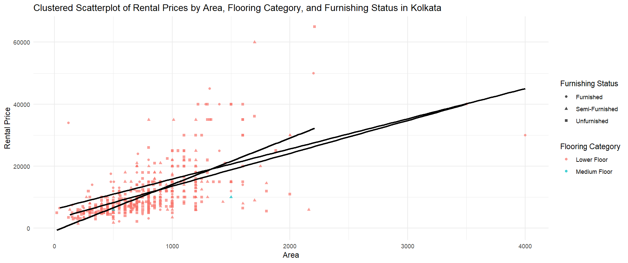

Analysis 4.24 Exploring Flooring Category, Area Size, Furnishing Status Impact on Rental Price in Mumbai

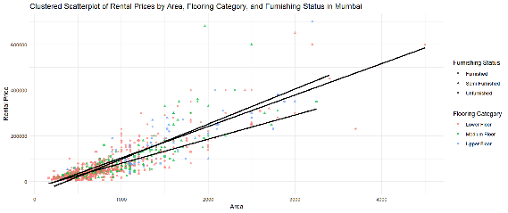

Analysis 4.25 Exploring Flooring Category, Area Size, Furnishing Status Impact on Rental Price in Bangalore

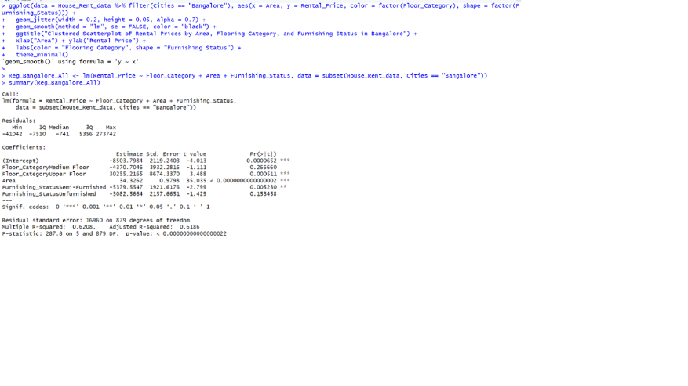

Analysis 4.26 Exploring Flooring Category, Area Size, Furnishing Status Impact on Rental Price in Delhi

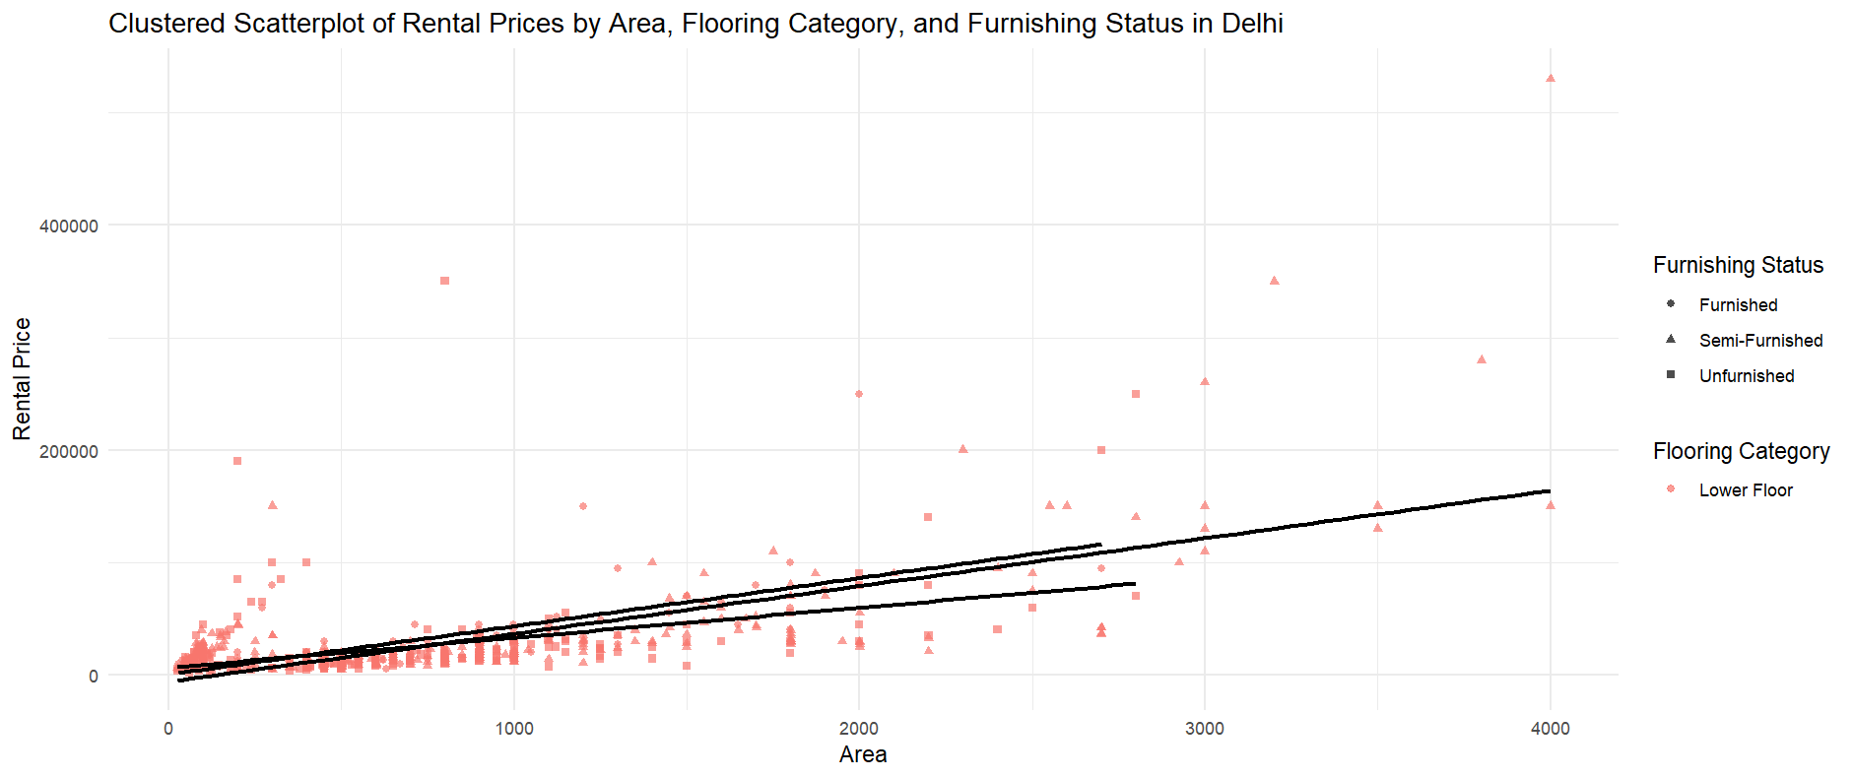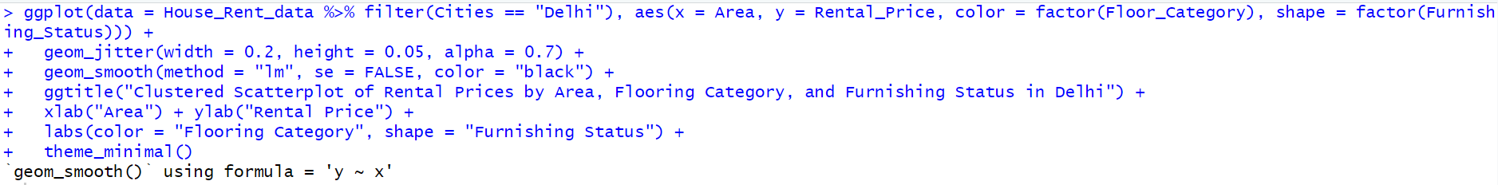

Analysis 4.27 Exploring Flooring Category, Area Size, Furnishing Status Impact on Rental Price in Chennai

Analysis 4.28 Exploring Flooring Category, Area Size, Furnishing Status Impact on Rental Price in Hyderabad

Analysis 4.29 Exploring Flooring Category, Area Size, Furnishing Status Impact on Rental Price across Each City

Analysis 4.30 Exploring the Highest, Medium, Lower Impact of the Rental Price